**Step 1: Connect to Azure Cloud Shell**

1. Go to the [Azure Portal](https://portal.azure.com).

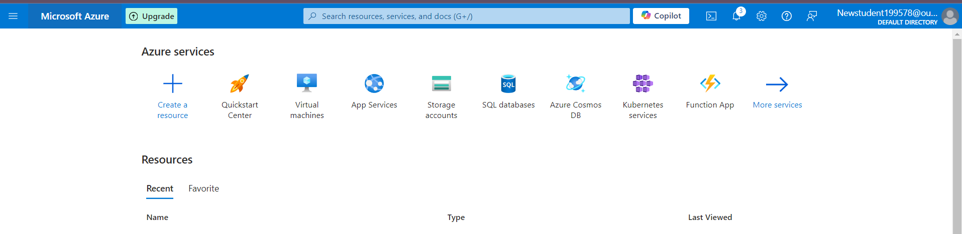

1. Click on the **Cloud Shell** icon (a terminal icon) at the top-right corner of the portal.

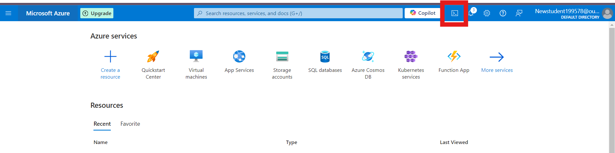

1. Select **PowerShell**.



1. The Cloud Shell will automatically connect to your Azure environment.

**Step 2: Create a Resource Group**

Once inside Cloud Shell:

**PowerShell:**

1. Run the following command to create the resource group:

**New-AzResourceGroup -Name "rg-1" -Location "South Central US"**

**1. Create 3 Storage Accounts with “Team” Tags**

# Create Storage Account for Team 1

**az storage account create --name shahidteam1 --resource-group rg-1 --location "South Central US" --sku Standard_LRS --tags team="team1"**

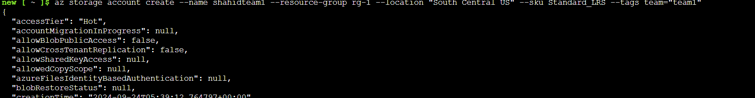

**Step 2: Create a Blob Container**

**az storage container create --name mycontainer --account-name shahidteam1**

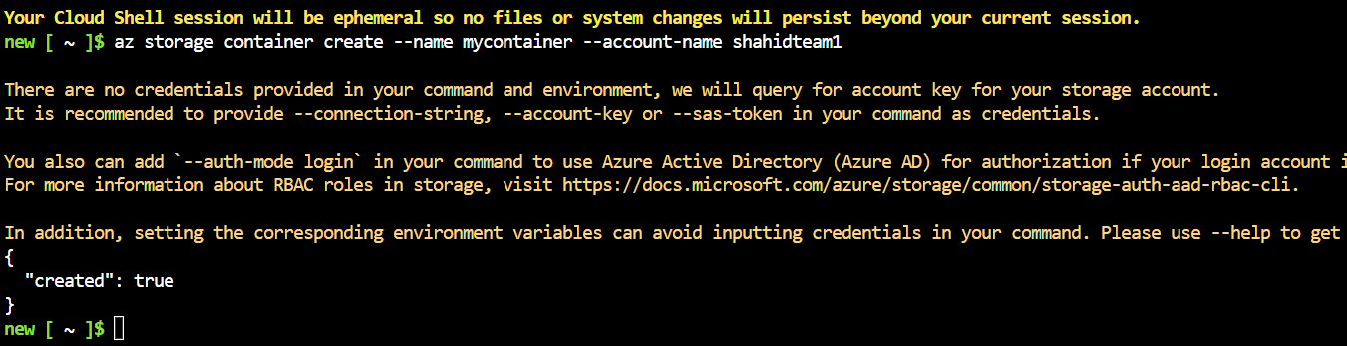

**Step 3: Upload Files**

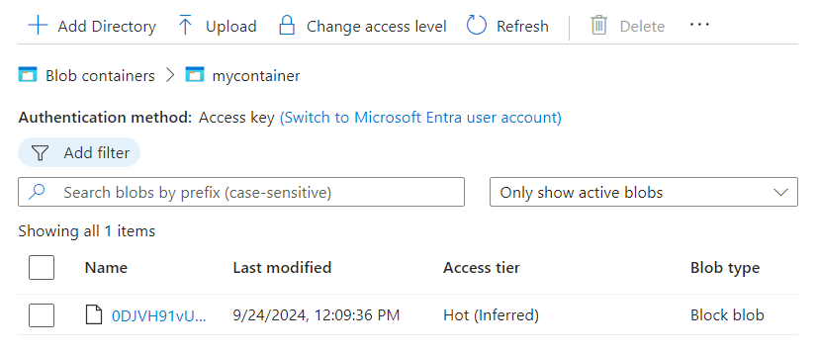

**2. Create a CDN Profile**

You can create a CDN profile using Azure CLI as well. Here’s how:

az cdn profile create --name myCDNProfile --resource-group rg-1 --location southcentralus --sku Standard_Microsoft

**3. Create a CDN Endpoint and Connect to Azure Blob**

**Step 1: Create a CDN Endpoint**

You can create a CDN endpoint that points to your Blob storage:

az cdn endpoint create --name myCDNEndpoint --profile-name myCDNProfile --resource-group rg-1 --origin mystorageaccount.blob.core.windows.net --origin-host-header mystorageaccount.blob.core.windows.net

**Step 2: Access Uploaded Files**

Once the CDN endpoint is created, you can access the uploaded files using the following URL structure:

https://myCDNEndpoint.azureedge.net/mycontainer/file.txt